Online Shopping System: FootFusion

Use-Case Specification: Delete Payment Methods

Version <1.0>

Revision History
Date | Version | Description | Author
23/11/2024 | 1.0 | Final Draft | Nguyen Minh Duc

Table of Contents
1. Delete Payment Methods 4
1.1 Brief Description 4
2. Flow of Events 4
2.1 Basic Flow 4
2.2 Alternative Flows 5
3. Special Requirements 5
4. Preconditions 5
5. Postconditions 5
6. Extension Points 5
7. Prototype 5

Use-Case Specification: Delete Payment Methods

Delete Payment Methods

Brief Description
This use case defines the steps of deleting a payment method in the database system. Administrator can easily delete payment methods from the options.

Flow of Events

Basic Flow
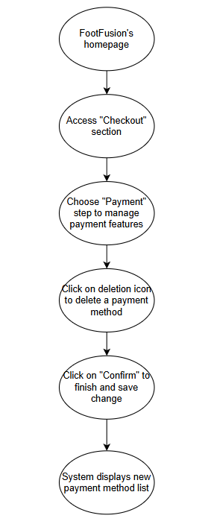

Alternative Flows
None.

Special Requirements
Administrator has basic knowledge of operating computer and user interface.

Preconditions
4.1. The administrator has logged in to an administrator account.
4.2. There is at least 1 payment method to delete.

Postconditions
The deleted payment method disappears from the method’s list.

Extension Points
There is no extension point.

Prototype

Figure 1: After managing the “Delivery” step or directly accessing the “Payment” step, the System will display this “Payment” step to manage payment methods

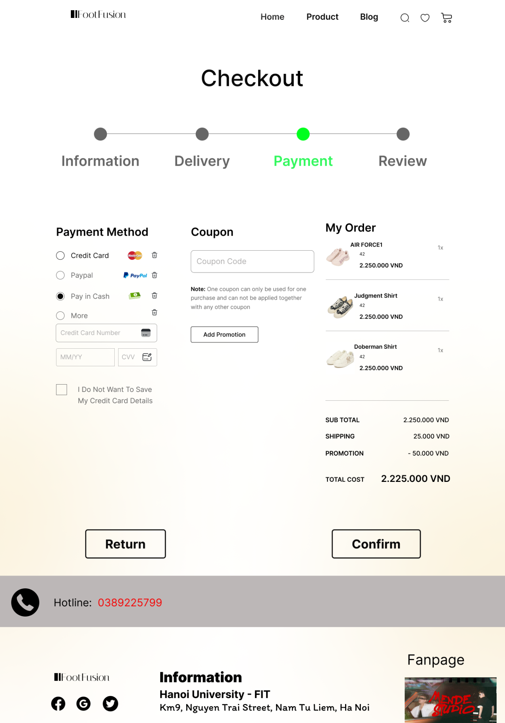

Figure 2: Some payment methods for the order can be chosen by clicking on the corresponding circle at the left. At the right side of each option, there is a “deletion icon”. Administrator can click on that icon to remove the method corresponding to it.

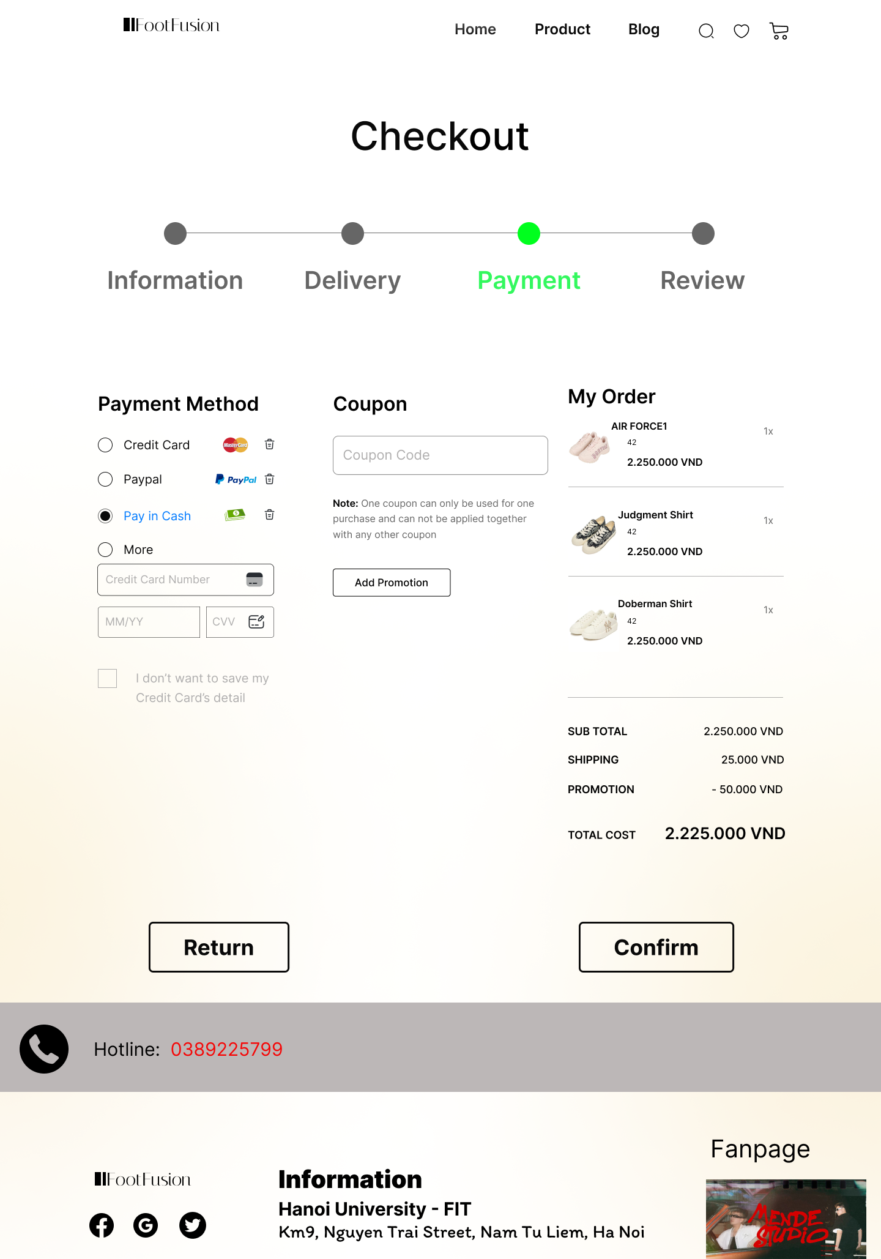
Deletion icon

Figure 3: After deleting a payment method, administrator clicks on “Confirm” button to save change and move to the last step

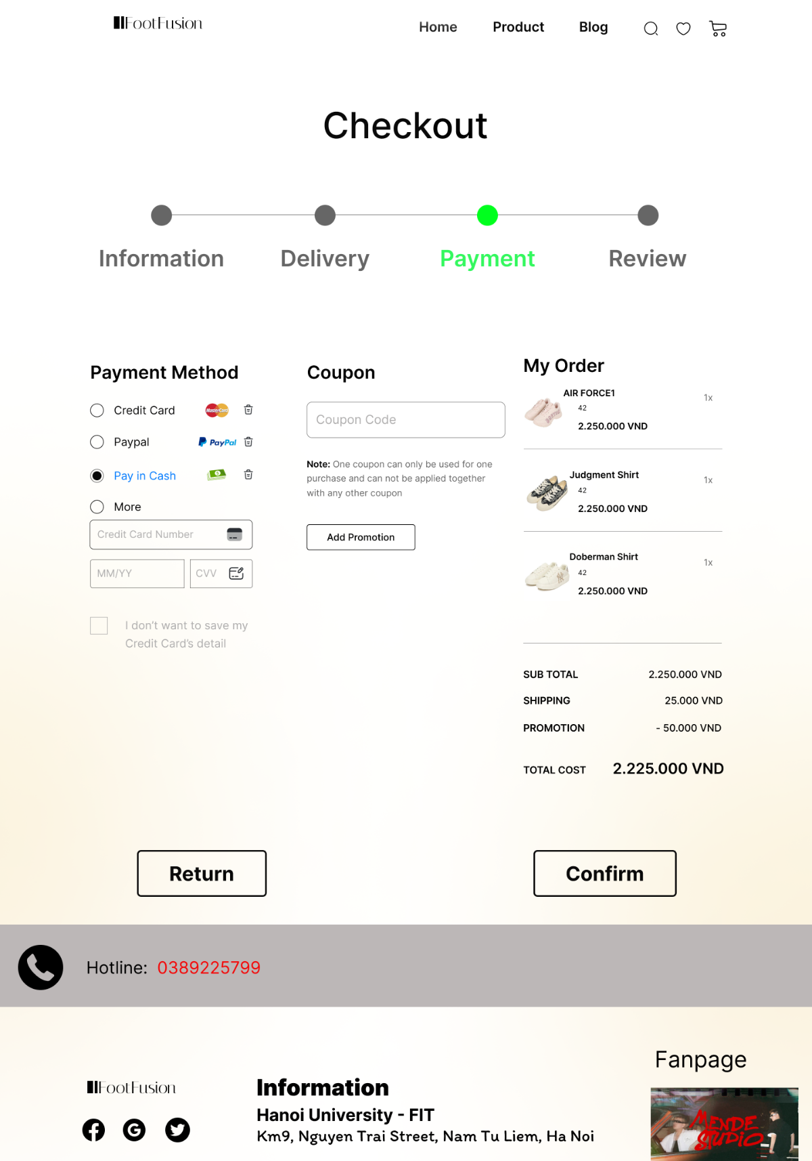
“Confirm” button

